Intent Cloud Refined Objectives and proposed Methodology

Objectives

- To design and implement a hybrid retrieval pipeline — combining local intent parsing (Phi-3 Mini), semantic embeddings, and keyword-based matching — capable of surfacing the correct file within the top-3 results for at least 85% of natural-language queries, tested on a corpus of 150+ mixed PDF/DOCX/TXT files. This directly targets the narrow, closed-set intent-classification limitation reported in [14], [15].
- To ensure the entire pipeline — text extraction, embedding generation, intent parsing, and reranking — runs fully on local hardware with zero calls to third-party LLM APIs, addressing the privacy and recurring-cost concerns raised by cloud-dependent RAG systems in [6], [7], [9], [11].
- To deliver the original requested file, rather than a generated summary, within roughly 15 seconds end-to-end on CPU-only consumer hardware. This overcomes both the "answer, not file" limitation seen in [6], [9], [11] and the GPU-cluster dependency reported for high-accuracy systems such as [8] and [16].
- To deploy the complete system — upload, indexing, hybrid retrieval, and serving — as a single self-hosted service reachable through one public HTTPS URL via Cloudflare Tunnel, since foundational work like [2] and [5] provides only algorithms, not a deployable system, and locally-hosted systems such as [13] remain confined to a single machine with no remote access.
- To empirically benchmark the hybrid, reranked pipeline against a plain keyword search and a dense-only semantic search on the same test set, so that the improvement from each added component (hybrid retrieval, reranking) is quantified rather than assumed.

Proposed Methodology

System Architecture & Workflow

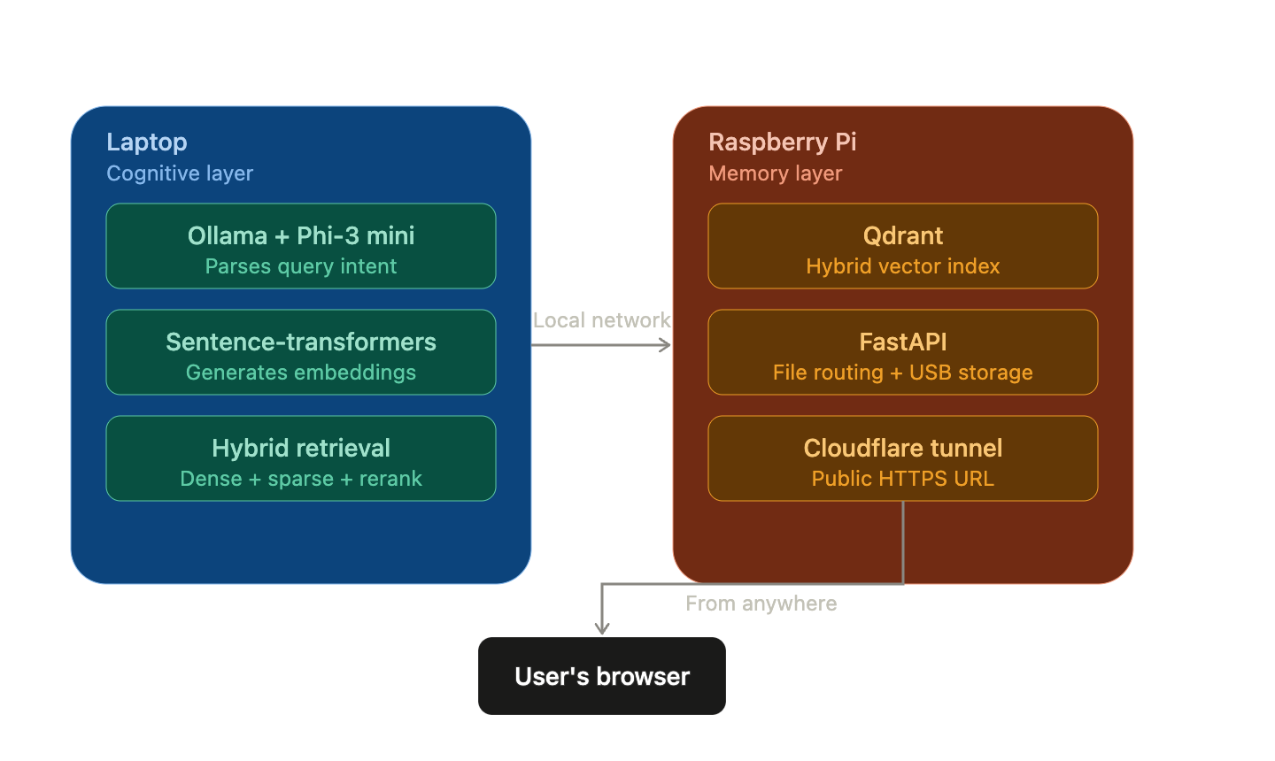
Figure 1. Laptop (cognitive layer) handles intent parsing, embedding, hybrid retrieval, and reranking; Raspberry Pi (memory layer) now runs Qdrant instead of FAISS, alongside file serving and the Cloudflare tunnel.
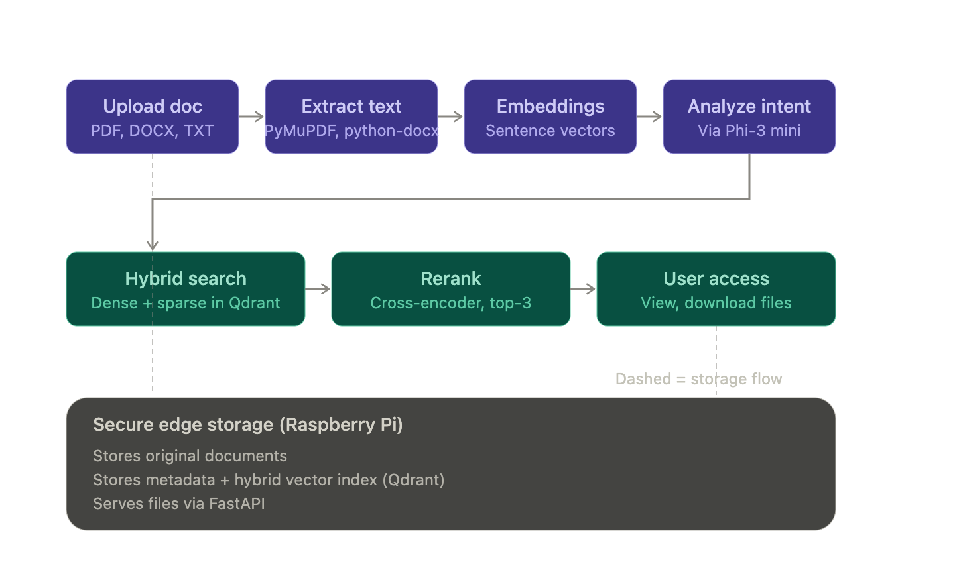
Figure 2. End-to-end request flow: upload → extract → embed → analyze intent → hybrid search (dense + sparse in Qdrant) → rerank → user access, all backed by secure edge storage

on the Pi.

Phase 1 — Data Ingestion & Preprocessing

- User uploads PDF / DOCX / TXT through the browser UI.
- Text extraction via PyMuPDF (PDF) and python-docx (DOCX) — fully offline, no per-document cost, avoiding the API dependency in [6],[7].

Phase 2 — Semantic Representation & Indexing

- Extracted text is converted to embeddings using built on the attention mechanism established in [2].
sentence-transformers
(all-MiniLM-L6),

- Index: Qdrant (embedded/local mode), replacing the originally proposed FAISS index. Justification:
  - Qdrant persists vectors and metadata (filename, topic tags, upload time) together, removing the need for a separate metadata store that a bare FAISS index would require.
  - It has native hybrid search (dense vector + sparse/keyword scoring) and payload filtering built in, which Phase 4 depends on — FAISS alone only does dense similarity search and has no keyword-matching layer.
  - It runs embedded on the Raspberry Pi without a separate server process, keeping the "consumer-grade hardware" constraint intact, and avoids the ~50GB-scale memory footprint reported for hybrid indexes at large corpus sizes in [8] — acceptable at our target scale of 150–200 files.

Phase 3 — Intent-Aware Query Understanding

- The natural-language query is parsed locally by Phi-3 Mini (via Ollama) into structured intent (topic/keyword JSON).
- Parsing happens on-device, avoiding the cloud dependency in [13] and generalizing beyond the closed-set, four-category classification in [14].
Phase 4 — Hybrid Retrieval & Reranking (replaces plain dense-only FAISS search)
- Dense retrieval: semantic similarity search over embeddings returns the top-N semantically closest candidates.
- Sparse/keyword retrieval: a BM25-style match runs in parallel, so an exact filename or keyword hit is never outranked by a merely topical one — directly targeting the failure mode observed in the earlier dense-only RAG attempt, and consistent with the accuracy gains from combining retrieval strategies reported in [8].

- Both retrieval modes are run through Qdrant's native hybrid-query support, which fuses dense and sparse scores in a single query rather than requiring two separate systems to be merged manually — this is the specific reason Qdrant was chosen over FAISS in Phase 2.
- Reranking: the merged candidate set is reordered by a lightweight local cross-encoder before the top-3 are shown, improving relevance beyond raw vector distance and providing the human-interpretable "why this matched" explanation missing in [3].

Phase 5 — Secure Storage & Remote Delivery

- Files, metadata, and the vector index persist on the Raspberry Pi 4B + USB storage (the edge node).
- Cloudflare Tunnel exposes one HTTPS endpoint — no port forwarding, no static IP — closing the "confined to a single machine, no remote access" gap in .

Phase 6 — Evaluation Plan

- Test corpus: 150–200 files spanning 5–8 topic categories.
- Query set: 30–50 natural-language queries, each with a known ground-truth target file, authored independently of the upload process to avoid bias.

Metrics:
  - Top-3 retrieval accuracy (%) — supports O1
  - Average end-to-end query latency (s), including reranking — supports O3
  - Accuracy delta vs. keyword-only baseline and vs. dense-only baseline — supports O5
- Reporting: results presented as a comparison table/chart in the final review, directly answering "how do you know hybrid retrieval actually improved things?"

